hub.docker.com

cmder.net

Powershell docker completion plugin  
<https://github.com/matt9ucci/DockerCompletion>

docker version  
docker info

docker container run --publish 80:80 nginx  
docker container run --publish 80:80 nginx:1.11  
docker container run --publish <host-machine-port>:<container-port> <docker-image-name>:<image-version>

1. If docker-image-name is found in the local image cache, docker uses it.
2. If not found, it downloads the image mentioned from the hub.docker.com and store it in the local image cache.
3. Starts the container by using that image. Gives a virtual IP in private network inside the docker engine.
4. Opens up host-machine-port on the host machine and forwards to container-port on the container.

docker container ls  
Lists the containers running on the host  
docker container ls -a  
Lists all the containers (running and not running) on the host  
docker container stop <container-unique-id>  
docker container run --publish 80:80 --detach nginx  
docker container run --publish 80:80 -d nginx  
--detach runs the container in the background but returns the container id created  
docker container run --publish 80:80 --detach --name **mycontainer** nginx  
**mycontainer** is the name given to the container. If not given, docker will assign some name automatically.  
docker container logs **mycontainer**  
Gets the logs from the mycontainer container  
docker container logs -f **mycontainer** Keepsfeeding the log continuously  
docker container top **mycontainer**Get the top few processes running in the mycontainer  
docker container rm <container-id1> <container-id2>  
Removes the containers if they are not running. Multiple container can be removed at the same time. If running -f forcefully deletes a running container. Stop and then remove.  
docker **container** –help  
List out all the sub commands relevant to **container** command  
docker run -it --rm --privileged --pid=host justincormack/nsenter1 (to be run from host machine. changes to mini linux vm terminal)  
Drops into a shell of the mini linux vm that is started by docker on windows.  
We can do ***ps aux*** to take a look at the processes running on the mini linux vm.   
If we run  
docker container run --publish 80:80 --detach --name mongo mongo (to be run from host machine)  
This actually starts mongod process in a container but the process is shown on the host machine’s mini linux vm that is created by docker.  
ps -aux | grep mongod (to be run from mini linux vm)  
If this mongo container is stopped using following command, we no more would see the mongo process inside the mini linux vm  
docker container stop mongo (to be run from host machine)  
ps -aux | grep mongod (to be run from mini linux vm. Now no mongo process will be found)

Assignment

docker container ls -a  
docker container run --publish 80:80 --detach --name **nginx** nginx  
docker container run --publish 8080:80 -d --name **httpd** httpd  
docker container run --publish 3306:3306 -d --name **mysql** -e MYSQL_RANDOM_ROOT_PASSWORD=yes mysql  
--env or -e allows provide environment variables during container creation.  
docker container logs mysql  
stop and remove containers

docker container top mycontainer  
docker container inspect mycontainer  
Spits out a lengthy json configuration about the mycontainer.  
docker container stats  
Displays CPU/Memory usage by each container on the host machine

Following allows to start a new ubuntu image container with name ‘proxy’ and start with ‘bash’  
docker container run -it --name **proxy** ubuntu bash (bash is now set as start up command for container)  
We are dropped into bash. We can now make all changes into ubuntu using the bash. Installing new packages etc. curl is not given by default in docker maintained ubuntu image.  
apt-get update (in ubuntu’s bash)  
apt-get install -y curl  
curl google.com  
exit  
To get back into the same container bash again and to make some more changes   
docker container start -ai **proxy**  
curl google.com (We are able to curl again. This means we are back in the same ubuntu image container that we modified)  
If we get ubuntu image again from the beginning then the curl will be lost.

Above was a new container with start command changed.  
How do we get into an existing running container?  
Run a new container -   
docker container run --publish 3306:3306 -d --name **mymysql** -e MYSQL_RANDOM_ROOT_PASSWORD=yes mysql  
Below command takes us into an existing running container that has mysql image and get into bash. Docker starts another process for bash in the same container and this does not impact the root process that the container is running with. In this case, mysqld (mysql daemon) root process is untouched but we start bash in another process.  
docker container exec -it mymysql bash  
We are now into an already existing container ‘mymysql’. Mysql image does not have ps command. So we will install in the container as we are already into bash now.  
apt-get update (run from bash)  
apt-get install -y procps (installing ps command from bash)  
ps aux (run from bash. We will see mysqld process running)  
  
  
docker pull alpine (A very light weight linux image 3.8 MB. We install required tools from scratch on the container having this image)  
Downloads the mentioned image  
docker image ls  
Lists the images in image cache

docker container run -p 80:80 –name webhost -d nginx  
docker container port webhost  
80/tcp -> 0.0.0.0:80  
docker container inspect --format ‘{{ .NetworkSettings.IPAddress }}’ webhost  
172.17.0.2  
ifconfig en0 or ipconfig (host machine)  
192.168.76.35

docker network ls  
Lists the networks created (**bridge** is the default network for containers, host is the one that avoids docker related security layers and connects to host networking directly, none is no network connection to the containers in it)  
docker network inspect **bridge**  
Lists the json with configuration information of the network.  
‘Containers’ section in the json lists what all containers are in this network.  
Also list the IPAM, Subnet used for the network.

docker network create my_app_net  
Creates a new network defaulted as bridge driver. (can provide --bridge value input if default is not desired)  
docker container run -d --name new_nginx **--network my_app_net** nginx  
docker network inspect my_app_net  
Will list the new_nginx container in the Containers section  
docker network connect <network-id> <container-id>  
Will put existing running container on a given network. The container at the same time can be on two networks.  
docker network disconnect <network-id> <container-id>

A new network created will automatically have a DNS enabled. Hence multiple containers inside that network are visible to each other using their container names. IP address need not and should not be used.  
docker container run -d --name new_nginx **--network my_app_net** nginx  
docker container run -d --name my_nginx **--network my_app_net** nginx  
Containers new_nginx and my_nginx are now in same network my_app_net.  
docker container exec -it new_nginx **ping my_nginx**  
We ping my_nginx container using its name from new_nginx container. Reverse as following also is true.  
docker container exec -it my_nginx **ping new_nginx**These two containers are visible to each other using their names because there is a default DNS in the new network created.  
This however is **not true** in case of the default **bridge** network. We explicitly have to mention the list of destination containers (--link to allow talking to) when creating the new container.  
It is lot better to create our own new network and allow the default DNS resolve the container names in that network.

-i interactive  
-t ttly like ssh  
container -a Attach  
-d detach  
container ls -a All  
 **Accessing ubuntu and centos parallelly**

docker container run -it --name ubuntu ubuntu:14.04 bash **(if --rm is included, the container will be disposed automatically once we exit)**  
apt-get update  
apt-get install -y curl  
curl –version  
>> curl 7.35.0  
docker container run -it --name centos centos:7 bash  
yum install curl  
>> curl 7.29.0  
  
**DNS Round Robin**

Create network that comes with DNS support by default  
docker network create dude  
Create and run a container with elasticsearch version 2 image. Name is given by docker engine automatically. -d means detach or run in background.  
docker container run -d --net dude **--net-alias search** elasticsearch:2  
Create and run another container with elasticsearch version 2 image. Name is given by docker engine automatically. -d means detach or run in background.  
docker container run -d --net dude **--net-alias search** elasticsearch:2  
Create and run a container (with -rm to dispose automatically at exit) with alpine image and run *nslookup* ***search*** (launch command) to see how many containers are reachable with DNS name ‘**search**’. This will list two containers. So we have two containers with same alias name though they have different/unique names.  
docker container run --rm --net dude alpine nslookup search  
Create and run a container (with -rm to dispose automatically at exit) with centos image and *run curl -s* ***search****:9200* (as launch command) to see which elastic server responds. The response comes from one of the two servers randomly.  
docker container run --rm --net dude centos curl -s search:9200  
docker container run --rm --net dude centos curl -s search:9200  
docker container run --rm --net dude centos curl -s search:9200  
docker container run --rm --net dude centos curl -s search:9200  
**Images and Tagging**   
<https://github.com/docker-library/official-images/tree/master/library>  
docker image ls  
docker image history nginx:latest  
works more like git commits. An image is a series of changes tracked by SHAs.  
docker pull nginx:latest & docker pull nginx:mainline. These both tags (latest, mainline) point to the same Image ID (like git commit id). Hence image is not duplicated but just having multiple tag names.

**COW – Copy Over Write**  
When a container uses an image, the image is read only. Any changes to the images are to be done by container, docker does a COW. Copy the file from image onto the container and write on it. This way multiple containers can use the same image while saving space and also having their own custom changes maintained local to that container.  
docker image inspect nginx:latest  
docker image inspect nginx  
docker pull mysql/mysql-server (not the official but organization based. Hence we have account mysql/ prefixed)  
  
**Giving new tag to existing image**  
docker image tag SOURCE_IMAGE[:TAG] TARGET_IMAGE[:TAG]  
docker image tag nginx:latest tezzzzz/nginx:latest  
REPOSITORY TAG IMAGE ID CREATED SIZE  
tezzzzz/nginx latest **ed21b7a8aee9** 4 days ago 127MB  
nginx latest **ed21b7a8aee9** 4 days ago 127MB  
docker login (defaults to docker hub. Can be changed)  
cat .docker/config.json (may store the session in user profile. Hence it is important to logout once done)  
docker image push tezzzzz/nginx  
#docker logout  
**Retagging the tezzzzz/nginx image with latest tag again as testing tag**   
docker image tag tezzzzz/nginx:latest tezzzzz/nginx:testing  
docker image push tezzzzz/nginx:testing

The push refers to repository [docker.io/tezzzzz/nginx]

d37eecb5b769: Layer already exists

99134ec7f247: Layer already exists

c3a984abe8a8: Layer already exists

testing: digest: sha256:7ac7819e1523911399b798309025935a9968b277d86d50e5255465d6592c0266 size: 948  
The green says that push is only considering the delta to push. Existing layer of the image already in repository will be skipped. Space and Network utilization.

**Dockerfile (default docker file name). During image build, use --file or -f is not default name.**To create an image – a recipe for docker image  
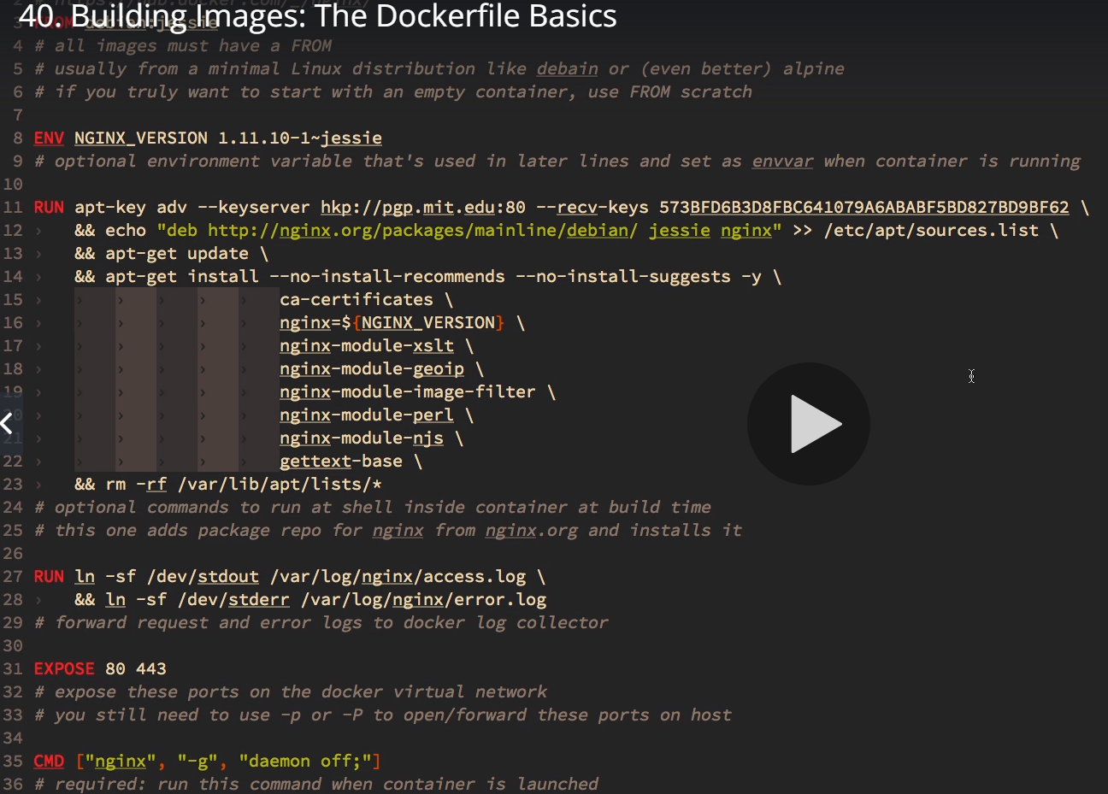  
From the folder that has Dockerfile run the following and it would build the image file and store in local image cache.  
docker image build -t customnginx **.**  
Each stance (FROM, ENV, RUN, EXPOSE, CMD, ARG) in the Dockerfile is taken as a step and cached. Each step is assigned imageid and layered one over the other in sequence. If the Dockerfile is changed in future, this step process will help identify where to start rebuilding and till where to use the image cache. Reduces build time and increases reusage. Each step is a line in the docker file.  
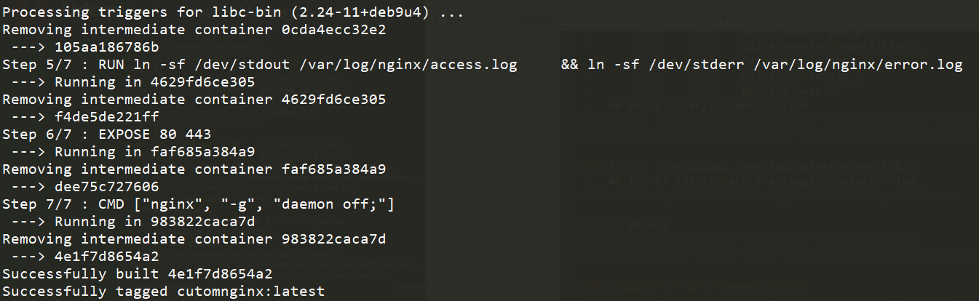  
docker image ls  
This will show the customnginx image created.  
After making line change in EXPOSE stance (step 5 in Dockerfile), the next image build used cache till Step 4.  
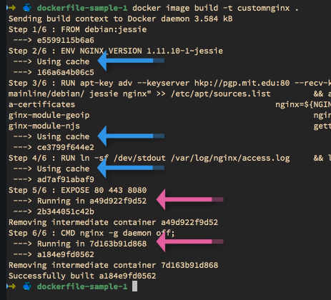  
**Good practice while writing a Dockerfile** is to have things that change the least on top or as eaerly steps in the docker file and those the change often towards bottom or as later steps in the Dockerfile. This practice will ensure that image cache is used for the first few steps. Hence reducing build time.  
  
WORKDIR stance to change directory  
COPY to copy file  
  
Dockerfile-sample-2  
# this shows Dockerfile on how we can extend/change an existing official image from Docker Hub and change nginx to show custom #html on landing page  
FROM nginx:latest  
# highly recommend you always pin versions for anything beyond dev/learn  
WORKDIR /usr/share/nginx/html  
# change working directory to root of nginx webhost  
# using WORKDIR is preferred to using 'RUN cd /some/path'  
COPY index.html index.html  
# I don't have to specify EXPOSE or CMD because they're in my FROM

Dockerfile-assignment-1  
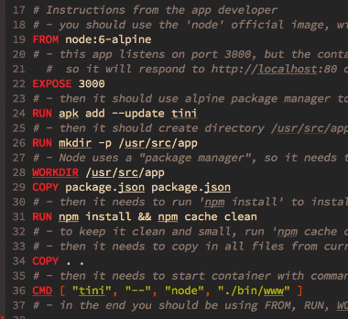  
docker image build -t testnode .  
docker container run –rm -p 80:3000 testnode  
<http://localhost>  
docker image tag testnode:tezzzzz/testing-node:latest  
docker push tezzzzz/testing-node:latest  
docker image rm tezzzzz/testing-node:latest  
docker container run --rm -p 80:3000 tezzzzz/testing-node

Cleaning up image cache  
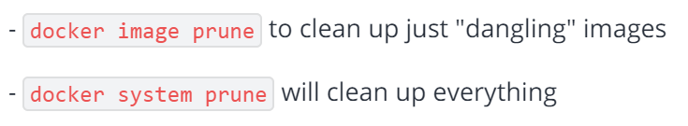

Docker container prune  
docker system df  
docker system prune -a (To consider deleting images as well and not just containers)

Dockerfile  
**VOLUME stance tells the path inside container to store the data generated by the container.**  
This path internal to container will also be pointed to another path on host machine.  
docker volume ls  
docker volume inspect <volume-id>  
docker container inspect <container-id> will show json that has Mounts section. **Source** is the actual storage on host machine pointed through **Destination** that is the storage internally to container.  
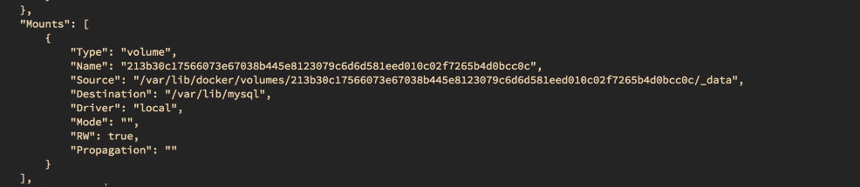  
  
Inspecting container would tell what Volume, Internal location owned by container, Actual location owned by host machine.   
On the other side, Inspecting volume would not tell which container is using the Volume.   
When containers are removed, volumes stay intact but we do not much about these volumes. Who owns it? Which volume maps to which container from Volume inspection.  
Auto-generated volume names only leave confusion. Hence when starting a container we shall give a user friendly volume name (Named Volume). So any new/upgraded version containers can reuse the same volume again.  
**Named Volume**  
docker container run -d --name mysql -e MYSQL_ALLOW_EMPTY_PASSWORD=True **-v mysql-db:/var/lib/mysql** mysql  
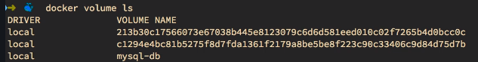  
**To determine the VOLUME used by original image, mysql or appropriate image docker file can be referred.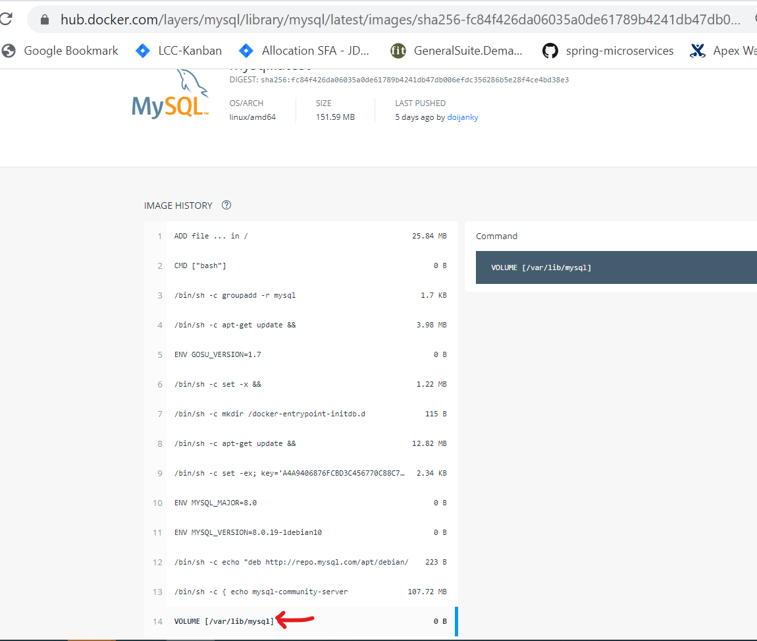 Mysql VOLUME above – Postgres VOLUME below**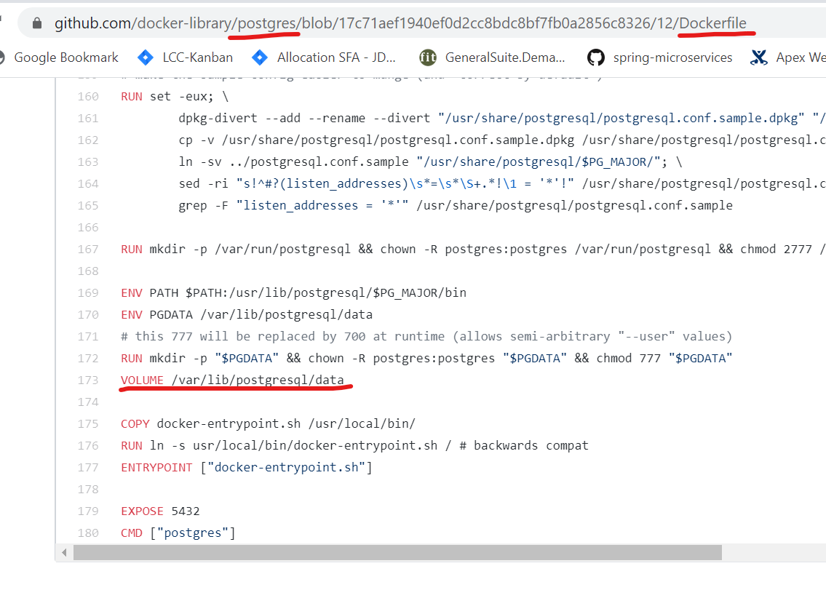

**Bind Mounting**Container uses the Host machines file system directly. We can modify the host system and the container will have the changes visible.  
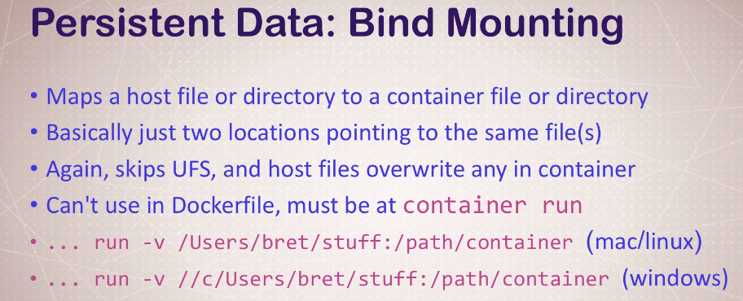  
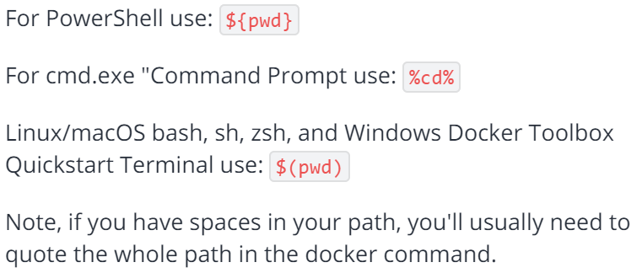   
Bind Mounting – The mounting done is not docker volume but file system on host machine directly.  
docker container run -d --name nginx -p 80:80 -v $(pwd):/usr/share/nginx/html nginx  
docker container run -d --name mynginx -p 80:80 **-v %cd%:/usr/share/nginx/html nginx**  
docker container run -d --name myjekyll -p 80:4000 **-v %cd%:/site bretfisher/jekyll-serve**  
docker container run -d --name myjekyll -p 80:4000 **-v %cd%:/site:ro bretfisher/jekyll-serve  
:ro – read only**  
Any references to /usr/share/nginx/html from within the container during the execution time will refer to present working directory.  
Any references to /site from within the container during the execution time will refer to present working directory.  
Any changes done in present working directory will be visible to nginx through /usr/share/nginx/html within container references.  
Any changes done in present working directory will be visible to Jekyll-server through /site within container references.  
*Which type of persistent data allows you to attach an existing directory on your host to a directory inside of a container?*  
Bind Mount

**Docker Compose**Docker compose is a better way to ‘docker container run’ command. Multiple containers information and dependencies among the containers can be listed in the form of a nice Yaml. Docker compose is a replacement of docker CLI.Default file **docker-compose.yml  
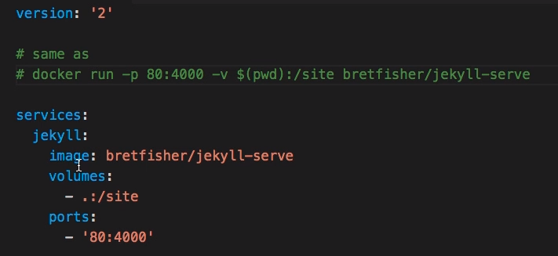**  
  
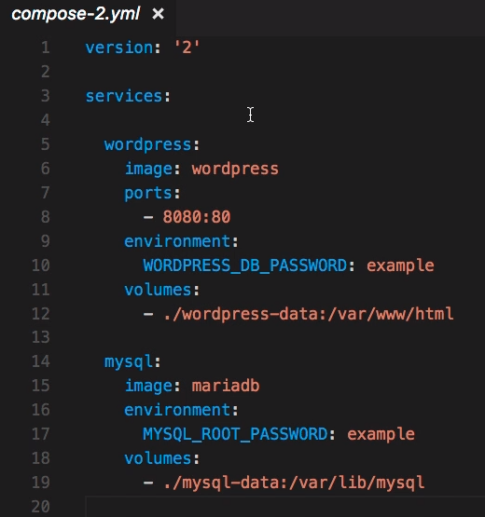

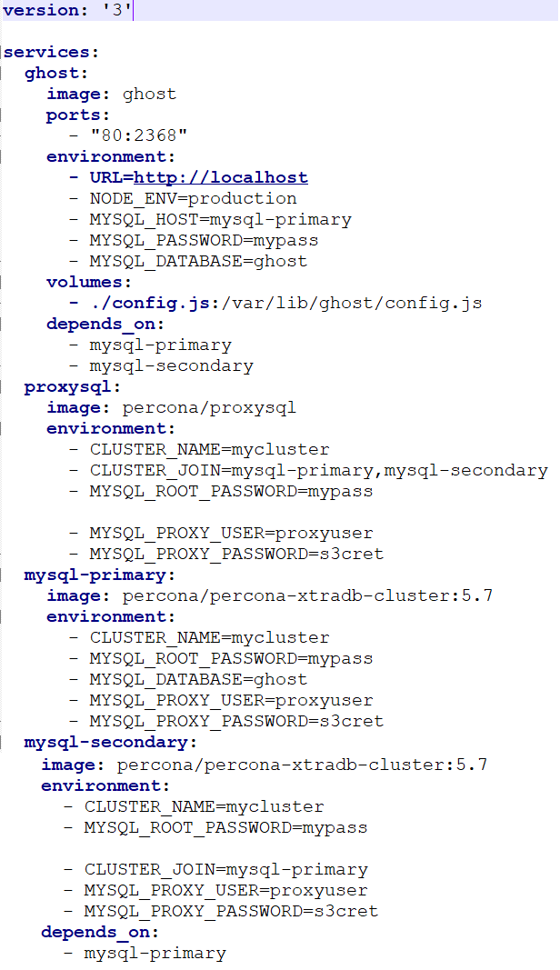  
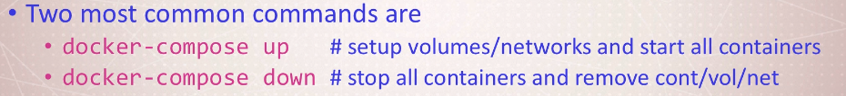docker-compose up -d  
docker-compose logs  
docker-compose ps  
docker-compose top (Lists top in each container)  
docker-compose down (tears down containers and deletes containers. Does not remove volumes.)  
docker-compose down -v (including volumes)  
Building image using docker-compose if the image is not found.   
‘build’, ‘context’, ‘dockerfile’, ‘image’ inputs can be provided.  
When container with name ‘proxy’ is to be run, docker creates the image if ‘nginx-custom’ image is not found in the image cache.  
This activity is equivalent to CLI docker image build -t nginx-custom .  
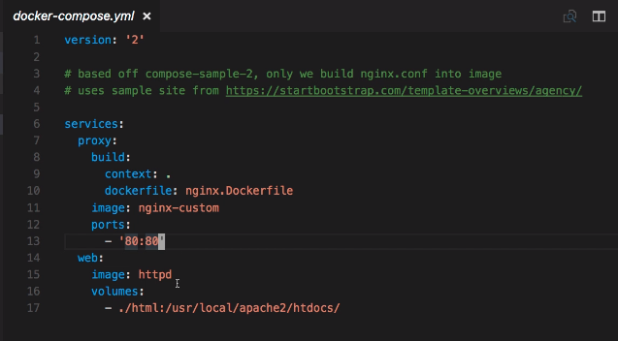  
First time, image is built. But of image changes in future ‘docker-compose up’ would not build the image automatically from next time. Use one of the following in such case.  
docker-compose build  
docker-compose up --build  
docker-compose down --rmi local (rmi – removes images built during docker-compose). This removal images is possible only if the image name is not specified in the docker-compose.yml file explicitly. Docker would assign the folder name + service/container name as the automatic image name. This automatic image created can be deleted with –rmi option during docker-compose down.

**Swarm***docker info*swarmcan be found inactive  
*docker swarm init*Initializesswarm*docker node ls*Shows that after swarm init, we have only one node and it is a Leader. We can add more nodes.  
*docker node --help  
docker swarm --help  
docker service--help*

*docker service create alpine 8.8.8.8*  
Creates one replica by default with alpine:latest image  
docker service ls  
Note the automatic name given to the service. Node name is not found here. Also note the sha-id of the service for increasing replicas later.  
docker service ps <service-name>  
Lists out the service name with replica number and also the automatic node name given.  
docker container ls  
*docker service update <service-sha-id> --replicas 3  
docker service ls  
docker service ps <service-name>  
docker update --help*Docker help allow change the memory or cpu configs on the container without bring the container down. But docker service update has lot more options.  
*docker service update --help  
docker container ls*Take a note of the first container name  
*docker container rm -f <container-name>*We removed one container but swarm will go ahead and recreate as we requested for 3 replicas.  
docker service ps <service-name>  
This will show the history that the container was stopped and that swarm recreated one right away.  
**play-with-docker.com** Create 3 nodes  
docker swarm init --advertise-addr 192.168.0.23  
docker network create --driver overlay mydrupal  
docker network ls  
docker service create --name psql --network mydrupal -e POSTGRES_PASSWORD=mypass postgres  
docker service ls  
docker service ps psql  
docker container logs psql.1.28k3k8vjwhn6c0yu2zcj668nj  
How to add nodes to swarm cluster?  
<https://docs.docker.com/engine/swarm/join-nodes/>  
docker swarm join-token worker  
The above command will spit out something like following which is to be run on all the worker nodes that would like to join the master node.  
docker swarm join --token SWMTKN-1-0lhz9wy0k7kk2flg9cowq2qftsce8nwz5ljtxzq84psrljp41i-4c7ffhq8ddhm229i5azm4f7aq 192.168.0.23:2377  
docker service create --name drupal --network mydrupal -p 80:80 drupal  
docker service ls  
docker service ps drupal  
Drupal can be found started on node2  
Now how to expose drupal to public internet?  
docker run --net host -ti jpetazzo/ngrok http <ip-address-of-node>:80  
ngrok by @inconshreveable (Ctrl+C to quit)

Session Status online

Session Expires 7 hours, 57 minutes

Update update available (version 2.3.35, Ctrl-U to update)

Version 2.1.18

Region United States (us)

Web Interface http://127.0.0.1:4040

Forwarding **http://bcdc80b1.ngrok.io** -> 192.168.0.23:80

Access <http://bcdc80b1.ngrok.io/>  
Though the drupal was found running on node2, we exposed node1 onto public ip using ngrok.  
Irrespective of the nodes in swarm using the network overlay, we see seamless behaviour as if the postgres and drupal are available on all nodes. All this magic is because of the network mesh.  
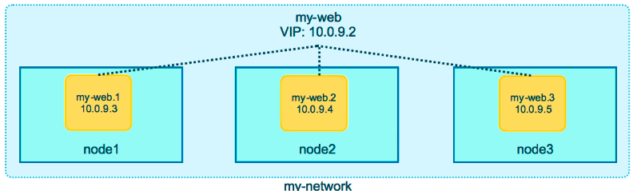  
  
Here is an example of traffic being routed to all 3 nodes created in play-with-docker.  
docker service create --name search --replicas 3 -p 9200:9200 elasticsearch:2  
[node1] (local) root@192.168.0.23 ~

$ curl localhost:9200

{

**"name" : "Captain Germany",**

"cluster_name" : "elasticsearch",

"cluster_uuid" : "T9j0Vgw6SmSBm_9VrcQIvw",

"version" : {

"number" : "2.4.6",

"build_hash" : "5376dca9f70f3abef96a77f4bb22720ace8240fd",

"build_timestamp" : "2017-07-18T12:17:44Z",

"build_snapshot" : false,

"lucene_version" : "5.5.4"

},

"tagline" : "You Know, for Search"

}

[node1] (local) root@192.168.0.23 ~

$ curl localhost:9200

{

**"name" : "G-Force",**

"cluster_name" : "elasticsearch",

"cluster_uuid" : "UUShujb-RYSc4FA7F6Q8Gw",

"version" : {

"number" : "2.4.6",

"build_hash" : "5376dca9f70f3abef96a77f4bb22720ace8240fd",

"build_timestamp" : "2017-07-18T12:17:44Z",

"build_snapshot" : false,

"lucene_version" : "5.5.4"

},

"tagline" : "You Know, for Search"

}

[node1] (local) root@192.168.0.23 ~

$ curl localhost:9200

{

**"name" : "Box IV",**

"cluster_name" : "elasticsearch",

"cluster_uuid" : "lf9G2dMSRkO0eYU8L4ZYPw",

"version" : {

"number" : "2.4.6",

"build_hash" : "5376dca9f70f3abef96a77f4bb22720ace8240fd",

"build_timestamp" : "2017-07-18T12:17:44Z",

"build_snapshot" : false,

"lucene_version" : "5.5.4"

},

"tagline" : "You Know, for Search"

}

[node1] (local) root@192.168.0.23 ~

$ curl localhost:9200

{

**"name" : "Captain Germany",**

"cluster_name" : "elasticsearch",

"cluster_uuid" : "T9j0Vgw6SmSBm_9VrcQIvw",

"version" : {

"number" : "2.4.6",

"build_hash" : "5376dca9f70f3abef96a77f4bb22720ace8240fd",

"build_timestamp" : "2017-07-18T12:17:44Z",

"build_snapshot" : false,

"lucene_version" : "5.5.4"

},

"tagline" : "You Know, for Search"

}  
*Routing Mesh is a stateless load balancing.*

A larger example with two overlay networks  
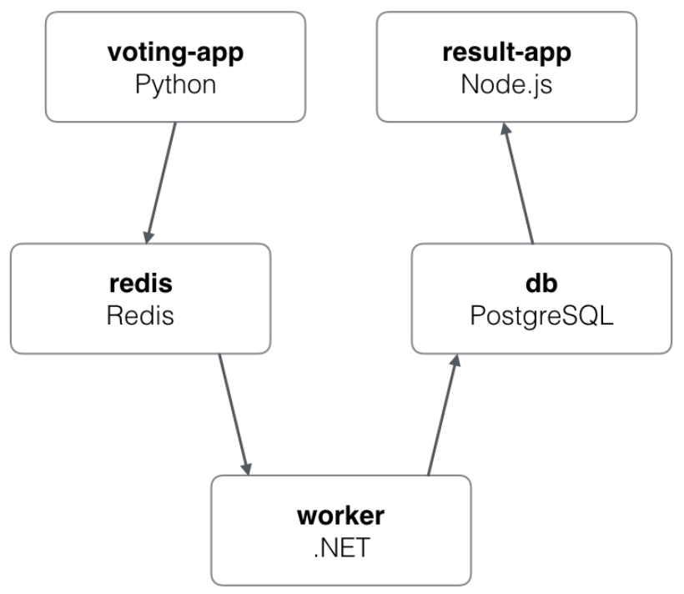  
worker is Java. Worker is on two networks.   
docker network create -d overlay backend

docker network create -d overlay frontend

docker service create --name vote -p 80:80 --network frontend --replicas 2 bretfisher/examplevotingapp_vote:before

docker service create --name redis --replicas 2 --network frontend redis:3.2

docker service create --name db --network backend -e POSTGRES_HOST_AUTH_METHOD=trust --mount type=volume,source=db-data,target=/var/lib/postgresql/data postgres:9.4

docker service create --name worker --network frontend --network backend bretfisher/examplevotingapp_worker:latest

docker service create --name result --network backend -p 5001:80 bretfisher/examplevotingapp_result

docker service logs worker

docker service ps worker

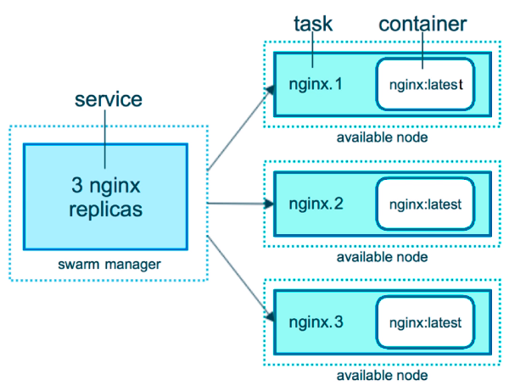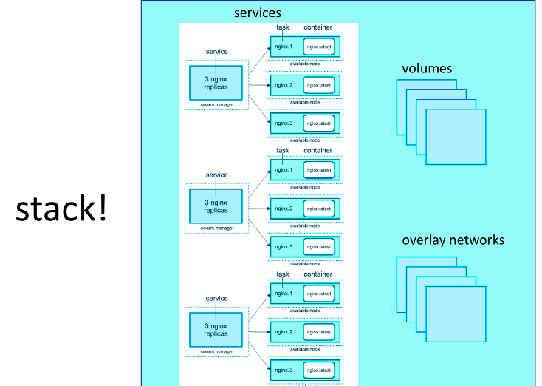  
Earlier voting app example now in docker stack  
version: "3"

services:

redis:

image: redis:alpine

ports:

- "6379"

networks:

- frontend

deploy:

replicas: 1

update_config:

parallelism: 2

delay: 10s

restart_policy:

condition: on-failure

db:

image: postgres:9.4

volumes:

- db-data:/var/lib/postgresql/data

networks:

- backend

environment:

- POSTGRES_HOST_AUTH_METHOD=trust

deploy:

placement:

constraints: [node.role == manager]

vote:

image: bretfisher/examplevotingapp_vote

ports:

- 5000:80

networks:

- frontend

depends_on:

- redis

deploy:

replicas: 2

update_config:

parallelism: 2

restart_policy:

condition: on-failure

result:

image: bretfisher/examplevotingapp_result

ports:

- 5001:80

networks:

- backend

depends_on:

- db

deploy:

replicas: 1

update_config:

parallelism: 2

delay: 10s

restart_policy:

condition: on-failure

worker:

image: bretfisher/examplevotingapp_worker:java

networks:

- frontend

- backend

depends_on:

- db

- redis

deploy:

mode: replicated

replicas: 1

labels: [APP=VOTING]

restart_policy:

condition: on-failure

delay: 10s

max_attempts: 3

window: 120s

placement:

constraints: [node.role == manager]

visualizer:

image: dockersamples/visualizer

ports:

- "8080:8080"

stop_grace_period: 1m30s

volumes:

- "/var/run/docker.sock:/var/run/docker.sock"

deploy:

placement:

constraints: [node.role == manager]

networks:

frontend:

backend:

volumes:

db-data:

Running the stack deploy by providing the yaml input  
docker stack deploy -c example-voting-app-stack.yml voteapp  
docker stack ls  
docker stack ps voteapp  
docker stack services voteapp  
docker network ls

<http://ipaddress:5000> for voting  
<http://ipaddress:5001> for voting result  
<http://ipaddress:8080> for visualizer like below  
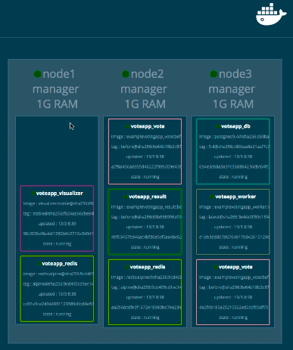  
Any changes done to docker compose file for stack, we just have to run the same command again  
docker stack deploy -c example-voting-app-stack.yml voteapp

**Secrets**Sensitive information is hidden and is exposed only to container and services that are supposed to use them.  
The secrets can be username, password, certificates etc.  
These secrets are cached in RAM file system but are exposed as if they are on hard disk. But they are not physically stored on hard disk in that location /run/secrets/<secret-name>.

docker secret create psql_user psql_user.txt  
Contents of the files as a secret. But we have a txt file sitting in there and it should be removed.  
echo “myDBpassWORD” | docker secret create psql_pass -  
Direct input as a secret. Bash history would tell what the password is which is not good.  
hyphen at the end allows take standard input. Here it takes it from the echo preceding it.  
docker secret ls  
docker secret inspect psql_user  
Just shows when it is crested and the ID but does not really show the sensitive information.  
docker service create --name psql --secret psql_user --secret psql_pass -e POSTGRES_PASSWORD_FILE=/run/secrets/psql_pass -e POSTGRES_USER_FILE=/run/secrets/psql_user postgres  
Bash into the container  
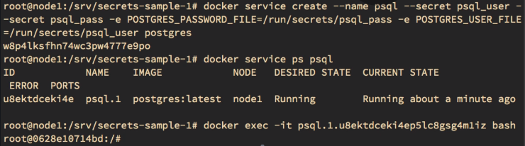  
**psql.1 is the Task and psql.1.u8ektdc… is the Container. One Task is created per container – I guess.**

cat /run/secrets/psql_user  
Crap it shows the value now here under psql_user secret.  
So, if we get inside a container, we will be able to see the secret data.  
docker service update --secret-rm  
Secrets are part of the immutable design of the containers. So, if anything is changed in the container, it restarts the container.

--secret-rm would remove the secrets but will redeploy/recreate a new container which is not desirable.

**Secrets with Stack**

Secrets can be provided through docker-compose file but have no meaning if not in Swarm. Secrets using in local without Swarm are not recommended for production deployments.  
version: "3.1"

services:

psql:

image: postgres

secrets:

- psql_user

- psql_password

environment:

POSTGRES_PASSWORD_FILE: /run/secrets/psql_password

POSTGRES_USER_FILE: /run/secrets/psql_user

secrets:

psql_user:

file: ./psql_user.txt

psql_password:

file: ./psql_password.txt

Along with docker-compose file, two files are provided with username and password in them.  
Version 3.0 for Stack usage but Version 3.1 to use Stack with secrets.

docker stack deploy -c docker-compose.yml mydb  
After that we will have to remove the text files manually.  
docker stack rm mydb  
This also removes secrets and network.

version: '3.1'

services:

drupal:

image: drupal:8.8.2

ports:

- "8080:80"

volumes:

- drupal-modules:/var/www/html/modules

- drupal-profiles:/var/www/html/profiles

- drupal-sites:/var/www/html/sites

- drupal-themes:/var/www/html/themes

postgres:

image: postgres:12.1

environment:

**- POSTGRES_PASSWORD_FILE=/run/secrets/psql-pw**

**secrets:**

**- psql-pw**

volumes:

- drupal-data:/var/lib/postgresql/data

volumes:

drupal-data:

drupal-modules:

drupal-profiles:

drupal-sites:

drupal-themes:

**secrets:**

**psql-pw:**

**external: true**

Here we are not referring to take the secrets from a file directly. But saying the the secrets are made ready externally and docker-compose or stack need not work about it. We will take care of creating the secret.

**Just a side note:**  
**build** that can be part of docker-compose file would help build the custom image by running Dockerfile. This is not anymore supported in Swarm mode from version 3.0. I guess and will have no impact. We are expected to have the docker images built already before getting into swarm. The build works for local docker-compose usage.

**Secrets in docker-compose mode  
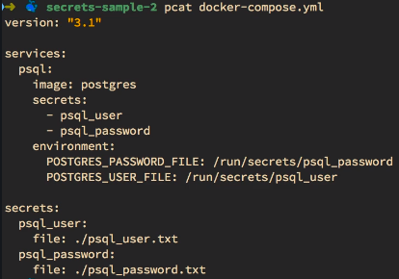**

When swarm is not initialized on the node, the same docker-compose file can be used but secrets are handled in a bind mount way which is one reason why docker0compose is not meant for production. The bind mount is only to allow usage of secrets in local setup too without making any changes. Not secure but it works for docker-compose. However the secrets work with only file based secrets but not external secrets.  
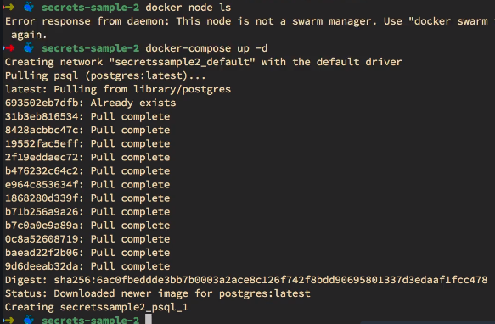



In case of not Stack/Swarm mode, for local or CI docker-compose usage, we can use docker-compose overriding feature.

Dockerfile  
docker-compose.yml  
docker-compose.override.yml  
docker-compose.test.yml

docker-compose.prod.yml

The docker-compose.yml can have the basic construct. The other files can have any overrides or extra stuff in there.

docker-compose up  
This would use docker-compose.yaml and apply docker-compose.override.yml over it.  
docker-compose -f docker-compose.yml -f docker-compose.test.yml up -d  
Applies test over the base yml file. The test docker-compose file may not use any bind mounts like override does. test is meant for CI usage and we do not want to retain any data from previous CI run.  
docker-compose -f docker-compose.yml -f docker-compose.prod.yml config

Base file followed by override file  
This just clubs both files and prints out put. So redirect to another file and run stack command.  
docker-compose -f docker-compose.yml -f docker-compose.prod.yml **config** > output.yml  
docker stack deploy can be used if referred to output.yml  
The **config** option might not consider secrets while merging which was a but but might have fixed.

Compose **extends** section is another nice declarative way to specify in docker-compose if there multiple files and we want to split/reuse.

Swarm service update examples  
docker service update --image myapp:1.2.1 <service-name>  
docker service update --env-add NODE_ENV=production --publish-rm 8080  
docker service scale web=8 api=6  
  
docker service create -p 8088:80 --name web nginx:1.13.7  
docker service ls  
docker service scale web=5  
docker service update --image nginx:1.13.6 web  
It removes the container and then recreates by doing rolling updates one container after the other across all the nodes  
docker service update --publish-rm 8088 --publish-add 9090:80 web  
docker service update --force web  
Hack to distribute the Tasks evenly to all nodes if some of found doing nothing.  
  
**Healthchecks**  
Starting, Healthy, Unhealthy  
Services will replace tasks if health check fails  
Service update wait for positive health check result  
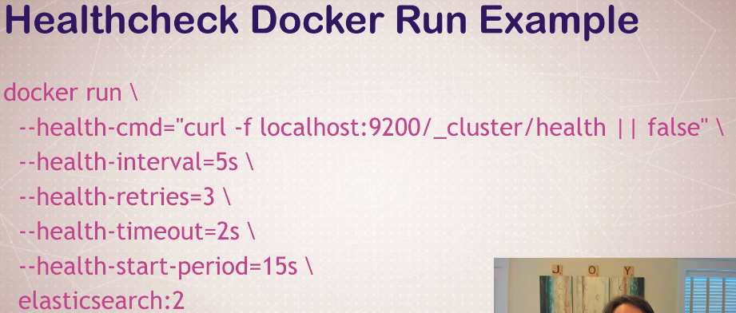  
9200 is the port inside the container. Not the one exposed.  
elasticsearch already has _cluster/health URI featured and we use that for health check.  
**|| false** is to return 1 when health check URL fails or timesout   
  
  
  
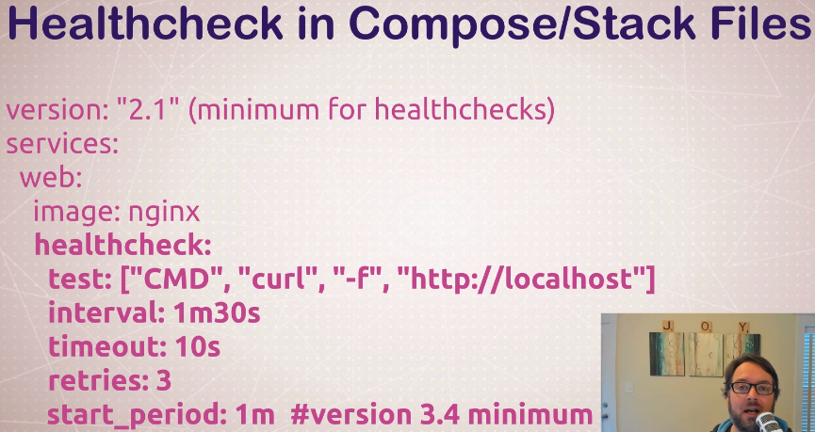  
  
docker container ls  
docker container inspect  
  
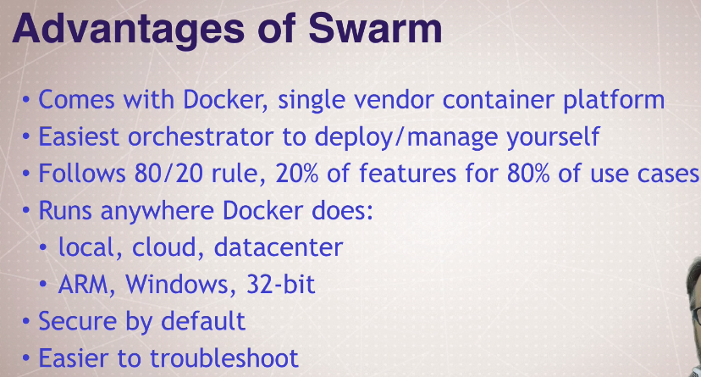

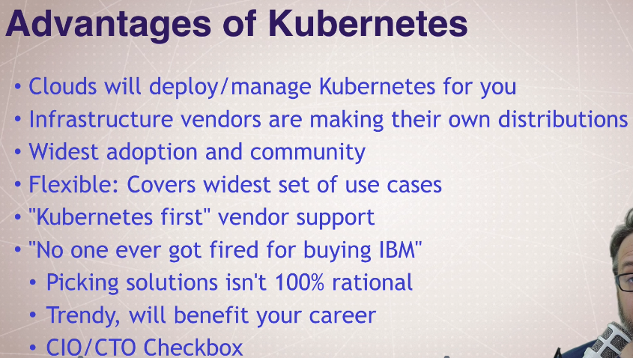

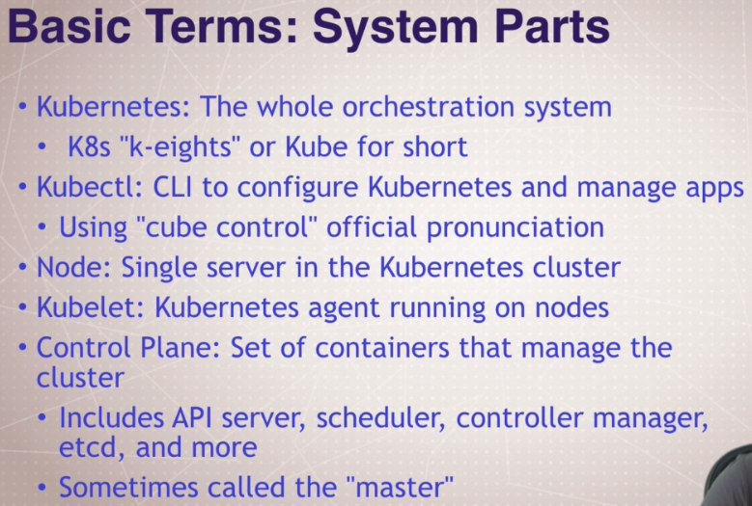  
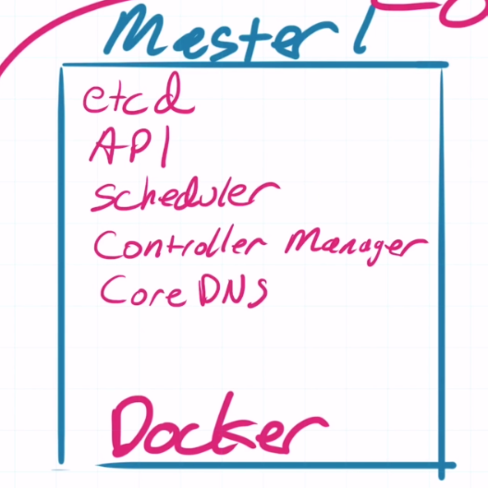 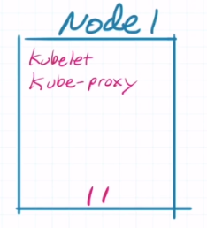  
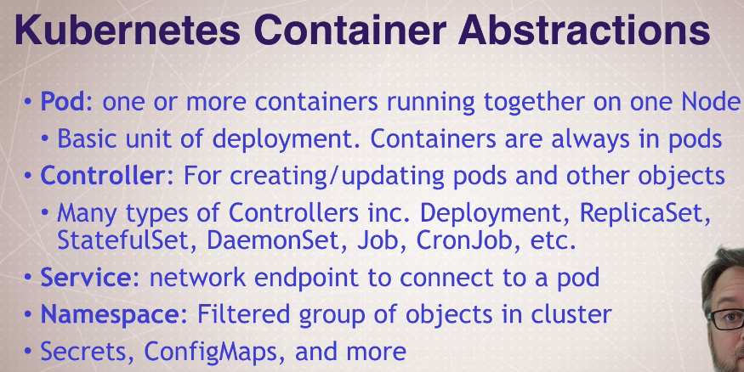

kubectl version  
kubectl run **my-nginx** --image nginx   
**my-nginx** is the name of the deployment.  
Above *kubectl run* command creates   
1. a pod having nginx container,   
2. a replica set over the pod,   
3. a deployment controller over the replica set  
  
service/Kubernetes is something that run all the time.

kubectl get pods  
NAME READY STATUS RESTARTS AGE  
**my-nginx**-948577f65-p6655 1/1 Running 0 4m18s

kubectl get all

NAME READY STATUS RESTARTS AGE  
pod/my-nginx-948577f65-p6655 1/1 Running 0 5m48s

NAME TYPE CLUSTER-IP EXTERNAL-IP PORT(S) AGE  
**service/kubernetes**  ClusterIP 10.96.0.1 <none> 443/TCP 23h

NAME READY UP-TO-DATE AVAILABLE AGE  
**deployment.apps/my-nginx** 1/1 1 1 5m48s

NAME DESIRED CURRENT READY AGE  
**replicaset.apps/my-nginx**-948577f65 1 1 1 5m48s

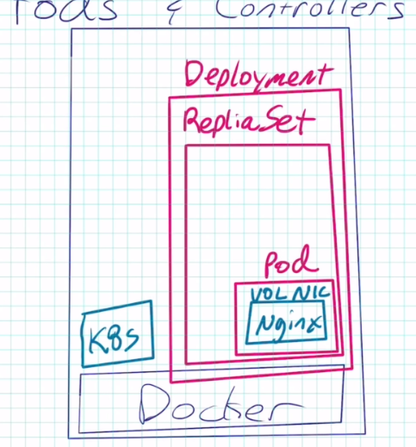Deployment controller’s job is to manage the replica sets and replica set template.  
Replica-set’s job is to make sure that the pods that are to be identical are maintained as expected.

Following would delete everything under that deployment – Deployment controller, Replica sets under it, Pods under the Replica sets, containers in each pod.  
kubectl delete deployment **my-nginx**deployment.extensions "my-nginx" deleted

Depending on which version of Kubernetes you have installed, you'll need to decide how you'll create objects. Here's a cheat sheet for how old commands should be used with the 1.18 changes.

kubectl **run** nginx --image nginx created a Deployment named nginx **before** 1.18 (which creates a ReplicaSet, which creates a Pod)  
kubectl **run** nginx --image nginx creates a Pod named nginx **in** 1.18+  
Creating a Deployment in 1.18:   
kubectl **create deployment** nginx --image nginx

kubectl run my-apache --image httpd  
kubectl get all  
  
Scaling up with another pod  
kubectl scale deploy/my-apache --replicas 2  
or  
kubectl scale deployment my-apache --replicas 2  
  
C:\cmder

λ kubectl get all

NAME READY STATUS RESTARTS AGE

**pod/my-apache-6b4dc47d85-g22w4 1/1 Running 0 10s**

NAME TYPE CLUSTER-IP EXTERNAL-IP PORT(S) AGE

service/kubernetes ClusterIP 10.96.0.1 <none> 443/TCP 3d

NAME READY UP-TO-DATE AVAILABLE AGE

deployment.apps/my-apache 1/1 1 1 10s

NAME DESIRED CURRENT READY AGE

replicaset.apps/my-apache-6b4dc47d85 **1 1 1** 10s

​C:\cmder

**λ kubectl scale deploy/my-apache --replicas 2**

deployment.extensions/my-apache scaled

​C:\cmder

λ kubectl get all

NAME READY STATUS RESTARTS AGE

**pod/my-apache-6b4dc47d85-g22w4 1/1 Running 0 12m**

**pod/my-apache-6b4dc47d85-hjckt 1/1 Running 0 9s**

NAME TYPE CLUSTER-IP EXTERNAL-IP PORT(S) AGE

service/kubernetes ClusterIP 10.96.0.1 <none> 443/TCP 3d

NAME READY UP-TO-DATE AVAILABLE AGE

deployment.apps/my-apache 2/2 2 2 12m

NAME DESIRED CURRENT READY AGE

replicaset.apps/my-apache-6b4dc47d85 **2 2 2** 12m  
What actually happened?  
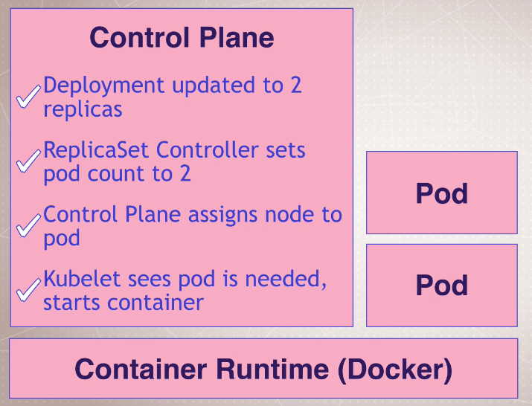

Getting logs  
kubectl logs deployment/my-apache  
Indicates that there are 2 pods founds but reads log by default from only one pod  
kubectl logs deployment/my-apache --follow --tail 1  
-- follow keep waiting for log updates and show  
-- tail start only from last line from already existing log  
kubectl logs -l run=my-apache  
Deployment controller labelled all the pods with the name of deployment. So the -l would help get logs from all the pods that are labelled as my-apache. So we would here get logs from 2 pods.  
By default Kubernetes can pull logs from up to 5 pods but more than that needs config changes. Also it is difficult to understand.  
**Stern** is one tool that can be used to color code the logs and make it little easier.  
  
Describing – like Inspecting docker containers  
kubectl get pods

NAME READY STATUS RESTARTS AGE

**my-apache-6b4dc47d85-g22w4** 1/1 Running 0 54m

my-apache-6b4dc47d85-hjckt 1/1 Running 0 41m  
  
kubectl **describe pods/my-apache-6b4dc47d85-g22w4  
describe** here not only shows the details of the pod but also shows events in the pod.

pod/pods & deploy/deployment/deployments –In Kubernetes commands singular or plural can be used interchangeably.

Even if we issue delete pod command, deployment controller will instruct to create another pods because the Kubernetes spec (earlier command *kubectl scale deploy/my-apache --replicas 2*) is set to maintain 2 pods.  
kubectl delete pod/my-apache-6b4dc47d85-g22w4  
Observe what is happening during the delete of pod using following command. We will see a pod created again very soon  
kubectl get pods -w  
-w – Continuously watches for changes in the outcome of the given command.  
kubectl delete deployment **my-apache**Deletes all the deployment under my-apache

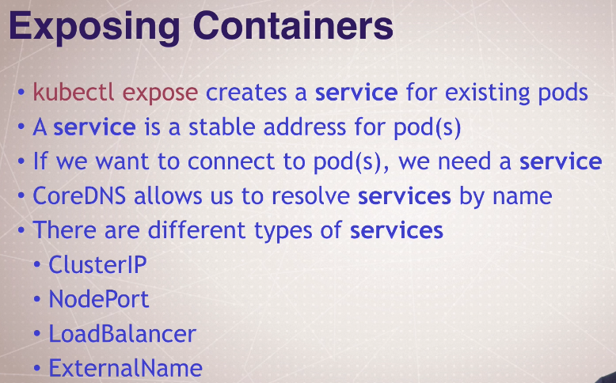

Kubectl get pods -w  
kubectl create deployment **httpenv** --image=bretfisher/httpenv  
kubectl scale deploy/**httpenv** --replicas=5  
kubectl expose deploy/**httpenv** --port **8888**This creates serviceendpoints to access the deployment.  
Exposing the deployment having 5 pods and listening on 8888  
kubectl get services

NAME TYPE **CLUSTER-IP** EXTERNAL-IP PORT(S) AGE

httpenv ClusterIP 10.97.188.235 <none> **8888**/TCP 82s

kubernetes ClusterIP 10.96.0.1 <none> 443/TCP 5d23h

Cluster IP is only usable inside the cluster for the nodes and pods to access the service.  
Not exposed outside Kubernetes world. Not accessible from Docker Desktop or Host machine.  
Need to be in a pod to access the cluster ip.

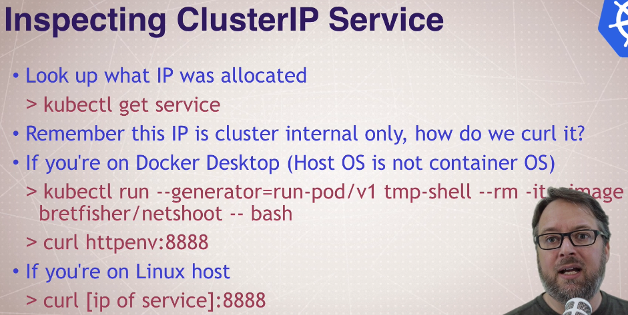

This following command on purpose is like ‘docker run’ command. Cluster IP is not accessible from host machine and hence we must get into a pod that runs on linux vm kubernates world and then curl to it. We can access httpenv deployment service (5 pods) using the cluster ip but only from Kubernetes pods or cluster. Hence we create an temporary pod just to curel and see if httpenv DNS name is exposed and responds on 8888.

If using Linux machine, cluster-ip can be used to curl but DNS name httpenv can be done only if inside a pod using the following command.

kubectl run --generator=run-pod/v1 tmp-shell --rm -it --image bretfisher/netshoot -- bash  
*--generator=run-pod/v1* Template to be used by Kubernetes. This template just creates pod but no replica set or deployment controller.  
*--rm* Remove the pod on exit  
*-it* Interactive and TTLY (like SSH)

*tmp-shell* Name of the pod

*-- bash* Drop into bash once the pod is running  
  
bash> curl **httpenv**:**8888**  
bash> curl **10.97.188.235:8888**

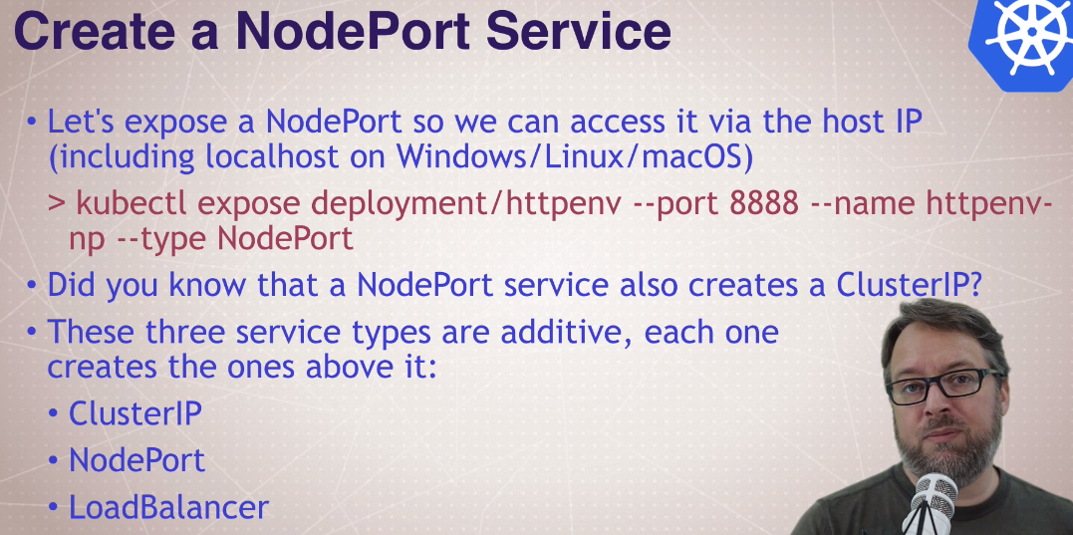

NodePort allows to expose the deployment onto the Host machine unlike the Cluster IP where we can access the Deployment only from Kubernetes world. So from Docker Desktop, we can access the Deployment. NodePort uses the Cluster IP but **exposes a random High Port** over the Cluster IP layer. Following, we can see that we have given name httpenv-np name for NodePort and it opens up **32262** and redirects the traffic to Cluster IP on port 8888 (NodePort is additive over ClusterIP). When compared to ‘Docker run’ ports (host-port:container-port), we have reverse here (deployment-port:host-port as **8888**:**32262**). So we can access the deployment on 32262 port directly from host machine.

kubectl expose deploy/httpenv --port 8888 --name httpenv-np --type NodePort

service/httpenv-np exposed

kubectl get services

NAME TYPE CLUSTER-IP EXTERNAL-IP PORT(S) AGE

httpenv ClusterIP 10.97.188.235 <none> **8888**/TCP 5h11m

httpenv-np NodePort 10.103.141.24 <none> **8888**:**32262**/TCP 18s

kubernetes ClusterIP 10.96.0.1 <none> 443/TCP 6d4h  
  
curl 127.0.0.1:32262

Over 32262 port **from host machine**, using an inbuilt VPNKit, we are able to connect to NodePort and the NodePort redirected the traffic to ClusterIP service listening on port 8888.

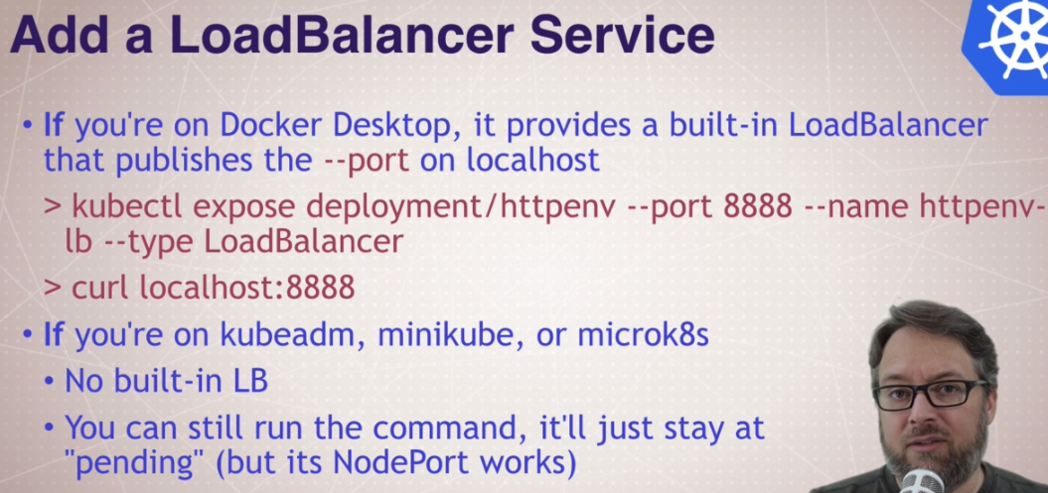

kubectl expose deploy/httpenv --port 8888 --name httpenv-lb --type LoadBalancer

NAME TYPE CLUSTER-IP EXTERNAL-IP PORT(S) AGE

service/httpenv ClusterIP 10.97.188.235 <none> 8888/TCP 6h19m

service/httpenv-lb LoadBalancer 10.96.76.40 localhost 8888:30428/TCP 7s

service/httpenv-np NodePort 10.103.141.24 <none> 8888:32262/TCP 68m

service/kubernetes ClusterIP 10.96.0.1 <none> 443/TCP 6d5h

curl localhost:8888

kubectl delete service/httpenv service/httpenv-np

kubectl delete service/httpenv-lb deployment/httpenv

kubectl get namespaces

curl <hostname>.<namespace>.svc.cluster.local

Run, Create, and Expose Generators  
kubectl create deployment sample --image nginx --dry-run -o yaml

--dry-run What-if mode. Not actually runs.  
-o yaml Displays yaml output that is generator template

apiVersion: **apps**/v1

kind: **Deployment**

metadata:

creationTimestamp: null

labels:

app: sample

name: sample

spec:

replicas: 1

selector:

matchLabels:

app: sample

strategy: {}

template:

metadata:

creationTimestamp: null

labels:

app: sample

spec:

containers:

- image: nginx

name: nginx

resources: {}

status: {}

kubectl create job sample --image nginx --dry-run -o yaml  
‘create job’ just creates a pod for one time usage (restart never) and does not include the deployment controller

apiVersion: **batch**/v1

kind: **Job**

metadata:

creationTimestamp: null

name: sample

spec:

template:

metadata:

creationTimestamp: null

spec:

containers:

- image: nginx

name: sample

resources: {}

**restartPolicy: Never**

status: {}

kubectl create deployment sample --image nginx  
kubectl expose deployment/sample --port 80 --dry-run -o yaml

apiVersion: **v1**

kind: **Service**

metadata:

creationTimestamp: null

labels:

app: sample

name: sample

spec:

ports:

- port: 80

protocol: TCP

targetPort: 80

selector:

app: test

status:

loadBalancer: {}

kubectl delete deploy/sample

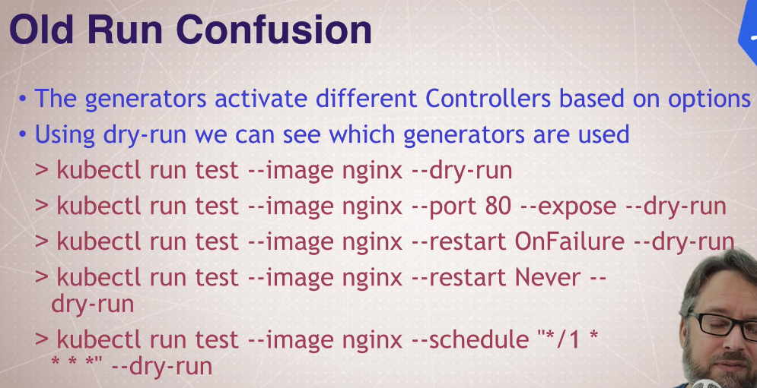

Above are old commands that use ‘kubectl run’ and are discouraged.

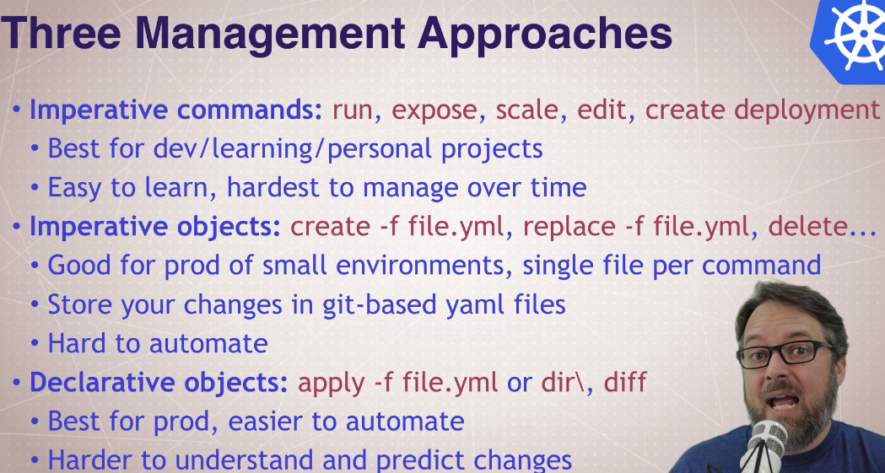

<https://kubernetes.io/docs/concepts/overview/working-with-objects/object-management/>

<https://kubernetes.io/docs/tasks/manage-kubernetes-objects/imperative-command/>

<https://kubernetes.io/docs/tasks/manage-kubernetes-objects/imperative-config/>

<https://kubernetes.io/docs/tasks/manage-kubernetes-objects/declarative-config/>

Imperative is good only when learning and for simple testing.

Declarative is recommended for Production and will help GitOps.

**Declarative Kubernetes Yaml** – kubectl apply

Kubectl apply -f myfile.yaml  
kubectl apply -f myyaml/  
kubectl apply -f <https://bret.run/pod.yml>

Read the YAML first 😊 before using it  
curl -L <https://bret.run/pod>  
start <https://bret.run/pod.yml>

Just one pod

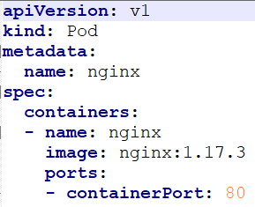

A deployment with replica set having 2 nginx pods

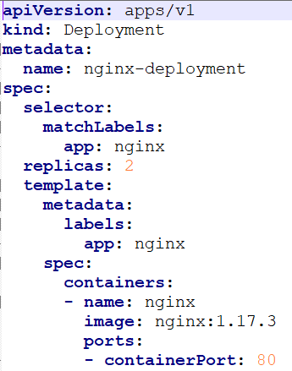

NodePort service created over A deployment with replica set having 3 nginx pods

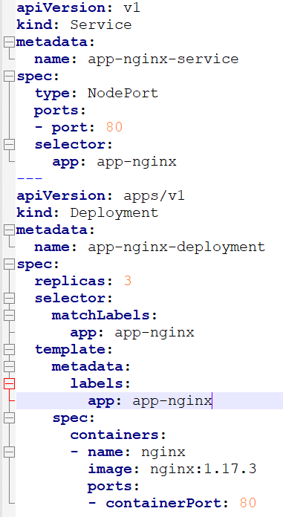

--- in a yaml is a separator. Before starting configuration of another resource, it can be used.

Each Yaml file needs these fours inputs to begin with and listed in the yaml. These will help understand what resource is to be created.

**Kind**: kubectl api-resources

Lists all the ‘Kind’s and API-Groups. Figure out the version based on the API-Group

**apiVersion**: kubectl api-versions

The combination of Kind & apiVersion will help determine the support in Kubernetes version  
**metadata**: only name is required

**spec**: This is where we mention all the complex input and the action to be taken.

We can get all the keys each **Kind** supports. Following spits out a syntax for **services Kind**.

kubectl explain services --recursive  
Too much of syntax/keys, very lengthy. Does not describe each line too ☹

We can get all the keys each **spec** in **Kind** supports. Following spits out a syntax for **spec** for **services Kind**.

kubectl explain services.spec  
This time we get description for **each key** in the spec

kubectl explain services.spec.type

This time we get description for **a specific key** in the spec

We can go very down nested in the spec and sub-spec. Following is an example.

kubectl explain deployment.spec.template.spec.volumes.nfs.server  
Online web API reference documentation

kubernetes.io/docs/reference/#api-reference

Following shows how to do dry run in client dry run in server, doing a diff with server yaml  
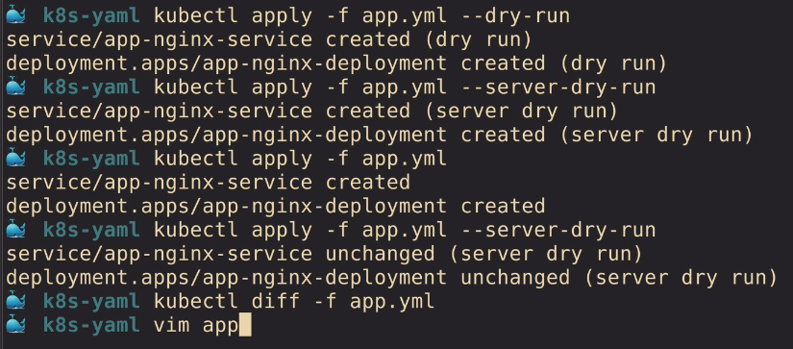

**Labels, Label Selectors and Annotations**

A marker on the resource created. These labels marked on resource help find based on certain pattern or key-value.  
Services want to find deployments and pods in it. So services can use labels to find matching deployments and pods in them.  
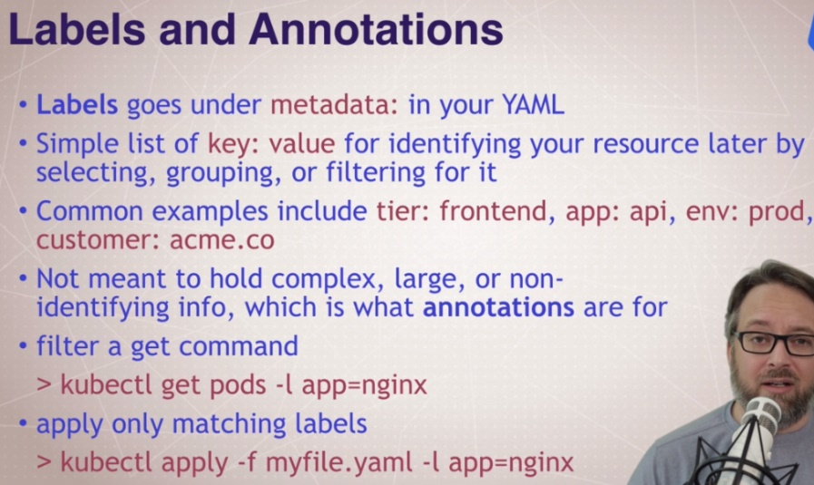  
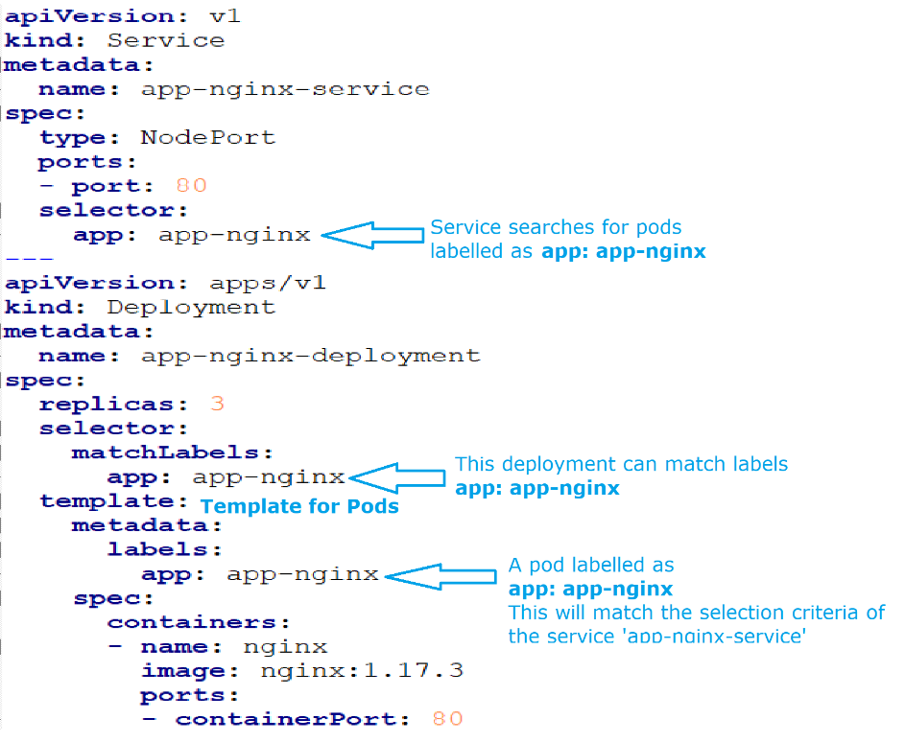

**Volumes in Kubernetes** (no examples taught)  
Volumes – Tied to lifecycle of a pod. All containers in the same pod can share the volume.

Persistent Volumes – Created at cluster level. Multiple pods can share the persistent volume.

**Ingress** (routing outside connections based on hostname or url)

Nginx, Traefix, HAProxy, F5, Envoy, Istio

**CRD’s and the Operator Pattern**  
Extending Kubernetes API and CLI

Automate deployment and management of complex apps

Eg: complex setup with Databases, monitoring tools, backups, and custom ingresses

<https://kubernetes.io/docs/concepts/extend-kubernetes/api-extension/custom-resources/>

<https://kubernetes.io/docs/concepts/extend-kubernetes/operator/>

Higher Deployment Abstractions

Kubectl commands just talk to the Kubernetes API

Kubernetes has limited built-in templating, versioning, tracking, and management of your apps

**Helm –** Templated yamlc- spit outs yamls that will then go into Kubernetes cluster.  
Helm is the most popular out of 80 3rd party tools

Docker compose yaml is docker’s way of creating containers and kubernates yaml is more complex and is Kubernetes’s way of creating containers/pods… But HELM makes it a standard way.  
HELM is one such Kubernetes application management tool and there are many more that can be found listed in this link  
<https://docs.google.com/spreadsheets/d/1FCgqz1Ci7_VCz_wdh8vBitZ3giBtac_H8SBw4uxnrsE/edit#gid=0>

<https://github.com/docker/compose-on-kubernetes/tree/master/docs> is one project that helps use the docker compose yaml on Kubernetes directly.  
<https://kubernetes.io/blog/2018/05/29/introducing-kustomize-template-free-configuration-customization-for-kubernetes/>  
<https://github.com/kubernetes-sigs/kustomize>

<https://github.com/docker/app>

<https://cnab.io/>

Kubernetes Dashboard  
<https://github.com/kubernetes/dashboard>

Namespaces and Contexts

Kubectl get namespaces

Kubectl get all -all-namespaces

Context -> Cluster, Authentication/User, Namespace

See ~/.kube/config

Kubectl config get-contexts

<https://12factor.net/>

THE TWELVE FACTORS that make a distributed app more successful  
Native SaaS mindset. All containers are to be planned in a way that they can recover and talk to other containers. 12factor is 12 principles that one must keep in mind for native SaaS solutions.

<https://www.oreilly.com/content/3-docker-compose-features-for-improving-team-development-workflow/>